District Nurse
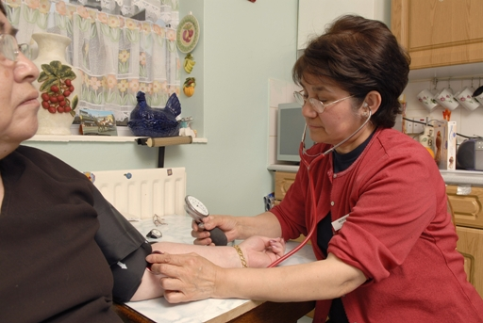
Mercedes Rojas came to London from Chile in 1997. She is a district nurse in London.
Mercedes at work as a district nurse
Photograph by Museum of London

‘At the moment I'm working as a district nurse, I'm working in the community. I've been in the job for quite a good few years, probably about seven years in the community, and going to visit people from home to home. Basically the population we cover is mainly elderly people. Their main professional in charge of their care is the GP and they work with a range of primary care team professionals: occupational therapists, district nurses, community nurses, as well as health visitors dealing with children. My work is very important. I was a nurse prior to coming to London, to England, and yes I think the caring aspect of the job was always something that I wanted to do and I will continue doing as far as or as long as I am able… Being a refugee, going through the difficulties we went through as a refugee, not having the language, feeling dependency, it was the hardest deed to come to this country. Because you’re in your country, you manage your own language, your job, your life, you’re independent, you’re a human being, you can move anywhere, and suddenly you have to come here and depend on people. We had to go at the very beginning to the social security for example. It was hard to accept and to go through and overcome it. And so through that I think it does help us to be more sensitive culturally to all other groups of people, certainly in my profession.’

